Experiment 4
Online train booking system

Aim
To develop a Train Reservation System website that allows passengers to search for trains, check seat availability, book and cancel tickets, check PNR status, and view refund details. The admin manages train information, fares, reservations, and passenger records.
Procedure
- Create a webpage using HTML for train reservation.
- Add passenger registration and login forms.
- Provide options to enter source, destination, journey date, and travel class.
- Display train details, ticket fares, and seat availability.
- Allow passengers to enter their details and book tickets.
- Generate a sample ticket and PNR number after booking.
- Provide options to check PNR status and cancel tickets.
- Display refund details after cancellation.
- Add an admin section to manage trains, fares, bookings, and passenger details.
- Test the webpage to ensure the basic functions work correctly.

Sample Code

<!DOCTYPE html>
<html>
<head>
<title>Train Reservation System</title>
</head>
<body>
<h1>Online Train Reservation</h1>

<h2>Passenger Login</h2>
<input type="text" placeholder="Username">
<input type="password" placeholder="Password">
<button>Login</button>
<button>Register</button>

<h2>Search Trains</h2>
<input id="from" placeholder="Origin Station">
<input id="to" placeholder="Destination Station">
<input type="date" id="date">

<select id="classType">
<option>Sleeper</option>
<option>AC 3 Tier</option>
<option>AC 2 Tier</option>
</select>

<button onclick="searchTrain()">Search</button>
<p id="trainResult"></p>

<h2>Book Ticket</h2>
<input id="passenger" placeholder="Passenger Name">
<button onclick="bookTicket()">Book Ticket</button>
<p id="ticket"></p>

<h2>Check PNR Status</h2>
<input id="pnr" placeholder="Enter PNR Number">
<button onclick="checkPNR()">Check Status</button>
<p id="pnrResult"></p>

<h2>Cancel Ticket</h2>
<button onclick="cancelTicket()">Cancel Ticket</button>
<p id="refund"></p>

<h2>Admin Panel</h2>
<p>Manage train details, fares, seats and reservations.</p>

<script>
let currentPNR = "";

function searchTrain() {
let from = document.getElementById("from").value;
let to = document.getElementById("to").value;

if (!from || !to) {
alert("Enter origin and destination.");
return;
}

document.getElementById("trainResult").innerHTML =
"Train available: " + from + " to " + to +
"<br>Sample seat availability: 20";
}

function bookTicket() {
let name = document.getElementById("passenger").value;

if (!name) {
alert("Enter passenger name.");
return;
}

currentPNR = String(Math.floor(
1000000000 + Math.random() * 9000000000
));

document.getElementById("ticket").innerHTML =
"Passenger: " + name +
"<br>PNR Number: " + currentPNR +
"<br>Status: Confirmed (Demo)";
}

function checkPNR() {
let pnr = document.getElementById("pnr").value;

document.getElementById("pnrResult").textContent =
pnr && pnr === currentPNR
? "Status: Confirmed (Demo)"
: "PNR not found.";
}

function cancelTicket() {
if (!currentPNR) {
alert("Please book a ticket first.");
return;
}

document.getElementById("refund").textContent =
"Demo ticket cancelled. Refund subject to applicable rules.";

document.getElementById("ticket").textContent =
"Ticket cancelled.";

currentPNR = "";
}
</script>
</body>
</html>

Output

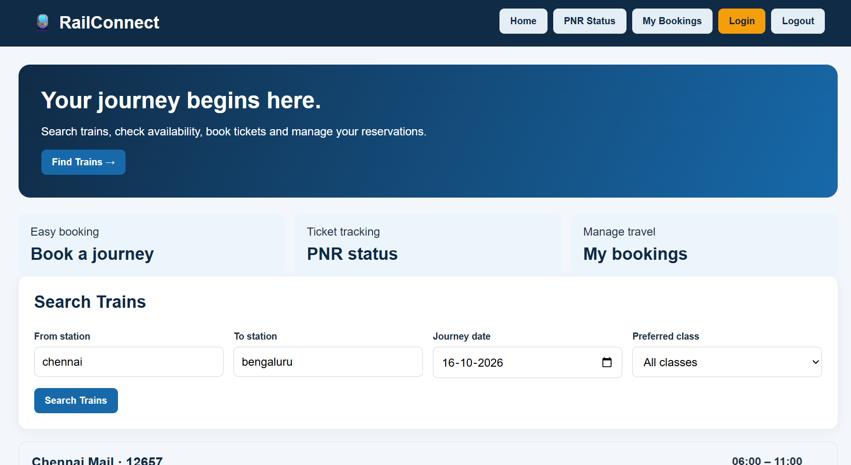

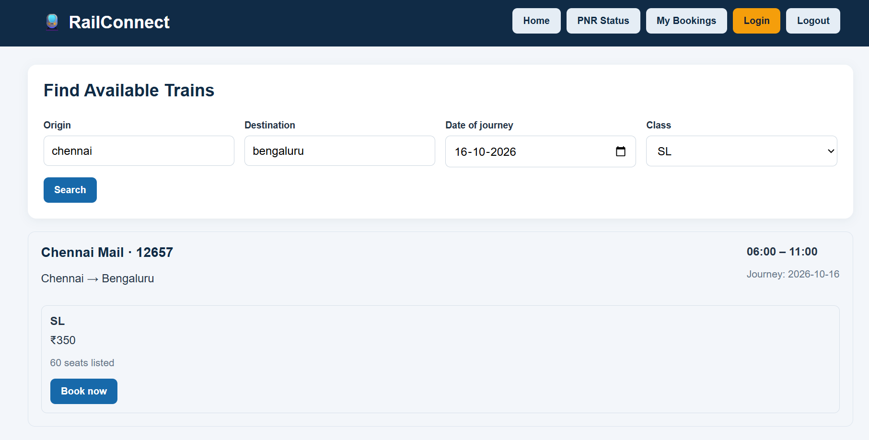

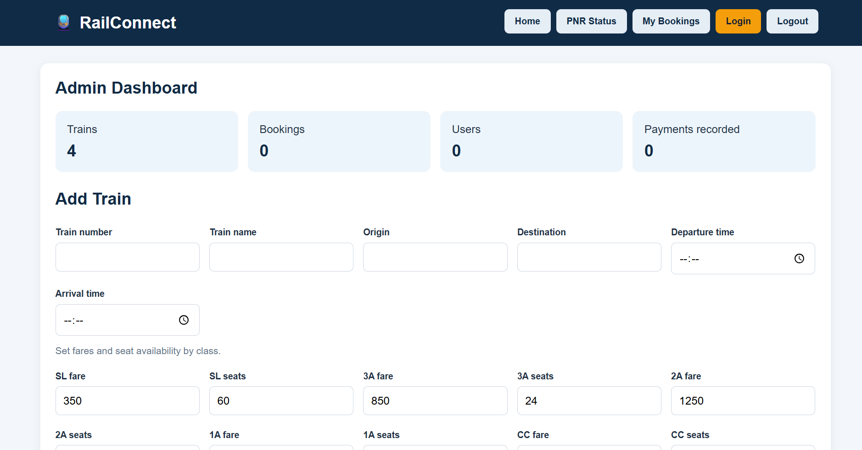

Result
The Train Reservation System webpage was created successfully. Passengers can enter journey details, search for trains, book sample tickets, check PNR status, and cancel tickets. The admin section represents train and reservation management. Real train schedules, seat availability, payments, PNR status, and refunds require a secure backend and railway data integration.

